Cyber Security Architecture

Theory
Designing Secure Architectures
A secure architecture combines network security and cloud security to protect applications, users, and data. It uses multiple layers of security (defense in depth), such as VLANs, firewalls, IDS/IPS, IAM, encryption, and cloud monitoring tools, to reduce the risk of cyberattacks.

Task 1: Network Diagram

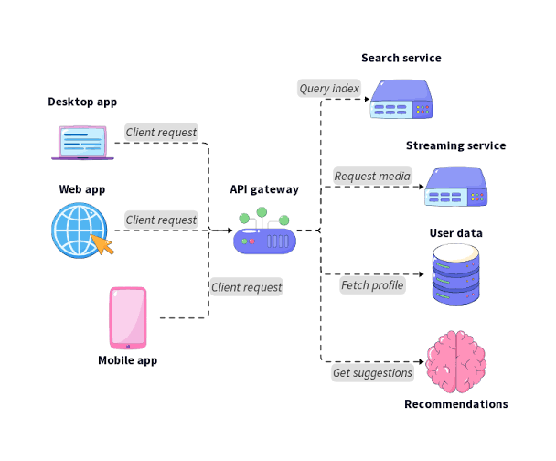

Task 2: IAM Policy (Read-Only Playlists)
{
"Version": "2012-10-17",
"Statement": [
{
"Sid": "AllowReadPlaylists",
"Effect": "Allow",
"Action": [
"music:GetPlaylist",
"music:ListPlaylists"
],
"Resource": "*"
},
{
"Sid": "DenyPlaylistModification",
"Effect": "Deny",
"Action": [
"music:CreatePlaylist",
"music:UpdatePlaylist",
"music:DeletePlaylist"
],
"Resource": "*"
}
]
}
This policy allows users to view playlists but prevents them from creating, editing, or deleting playlists.

Task 3: IDS Scenario
Scenario:
A customer places an order on a Zomato-like platform. An attacker suddenly sends hundreds of login requests from the same IP address within a few minutes, attempting to guess user passwords.
IDS Detection:
The IDS detects an unusually high number of failed login attempts from the same source IP and identifies it as a possible brute-force attack.
Alert Generated:
High Severity Alert

Possible Brute Force Attack Detected

Source IP: 192.168.1.25

Target: User Login Portal

Action: Notify Security Team

Task 4: Cloud Security Tool
Tool: AWS GuardDuty
AWS GuardDuty continuously monitors AWS accounts and workloads for suspicious activity using threat intelligence and machine learning.
Example (Flipkart-like E-commerce Platform):
- Monitor unusual IAM login attempts.
- Detect logins from unexpected countries.
- Alert on suspicious API calls.
- Identify cryptocurrency mining or malware activity.
- Detect unauthorized access to Amazon S3 buckets.
Response:
When GuardDuty detects suspicious behavior, it creates a finding. The security team can investigate the alert, block the affected account, enable MFA, or update IAM policies to prevent further unauthorized access.

Task 5: Secure Architecture Checklist
ChatGPT-Generated Checklist
- Divide the network into separate VLANs for users, administrators, and backend services.
- Configure firewalls to allow only required communication between network segments.
- Deploy IDS/IPS to monitor network traffic and detect malicious activity.
- Apply the principle of least privilege using IAM roles and policies.
- Enable Multi-Factor Authentication (MFA) for all administrator accounts.
- Encrypt sensitive data both in transit (TLS) and at rest (AES).
- Use cloud security tools such as AWS GuardDuty or Azure Security Center to continuously monitor for threats.
- Enable centralized logging and regular security audits.
- Keep operating systems and applications updated with security patches.
My Additional Suggestion
I would also implement regular automated backups and disaster recovery testing to ensure data can be restored quickly in case of ransomware, accidental deletion, or system failure.

